|  |
| --- |
| Sharknado games inc. |
| Shark Attack 2 – Side Scroller |
| COMP 397 – Assignment 4 |
| Version #0.2  All work Copyright © 2012 by XX Games.  All rights reserved. |
| **Aaron Fernandes & Arlina Ramrattan** |
|  |

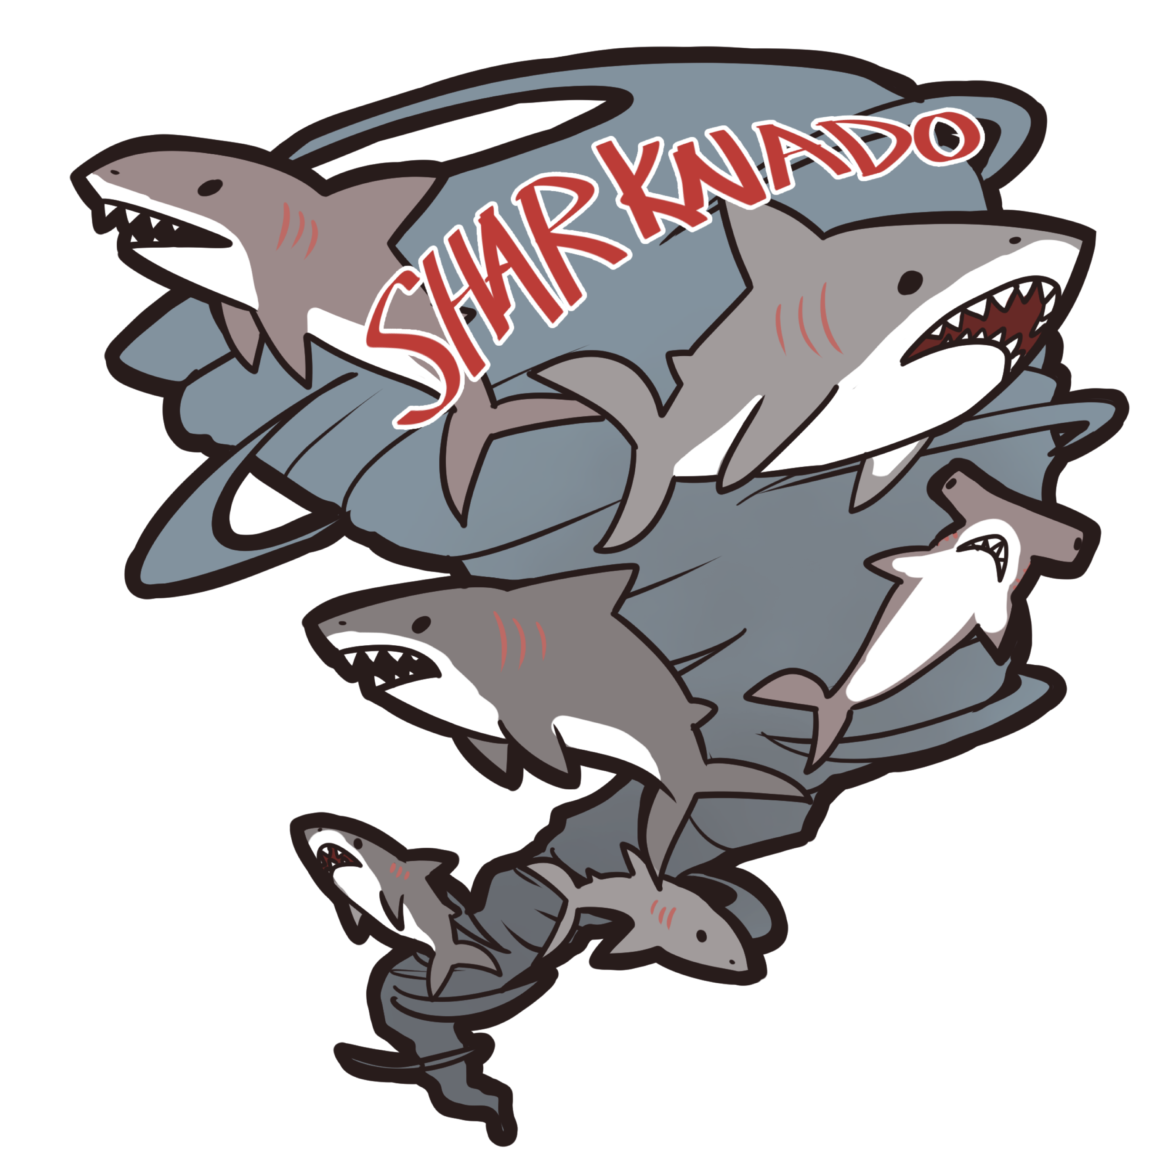

|  |
| --- |
| July 30th 2016 |

Table of Contents

Version History 3

V0.1 3

V0.2 3

Game Design 4

Game Overview 4

Controls 4

Interface Sketch 4

Menu Screen 4

Instruction Screen 4

Playing Screen 5

End Screen 5

Menu and Screen Descriptions 5

Menu Screen 5

Instruction Screen 6

Playing Screen 6

End Screen 6

Characters 6

Enemies 7

Scoring 7

Sound Index 7

Art / Multimedia Index 7

Game Link: 7

# Version History

## V0.1

* Added all base files (game.css, index.html, reset. css, core files, libs etc.)
* Added assets
* Added asset functionality
* Start scene and functionality
* Added background image & it’s functionality
* Added Menu & instruction Scene
* Added scene change mobility
* Added play scene

## V0.2

* Fixed issue with bubble movement
* Added collision class and collisions with player & shark
* Removed old and added new sounds
* Added Treasure
* Added Lives and score Labels
* Added instructions scene
* Added functionality to instructions and game over scene
* Added high score to game over screen
* Made bg-image less obvious

# Game Design

## Game Overview

This game Shark Attack 2 is a game where the player takes the role of a diver who is swimming in the ocean. They have to dodge sharks (enemies) while collecting treasure (points). The game goes on as long as the player has lives and there is no limit to how many points they player can get.

## Controls

Shark Attack 2 uses a mouse to direct whether the diver moves up or down. The diver cannot be moved left or right.

## Interface Sketch

### Menu Screen

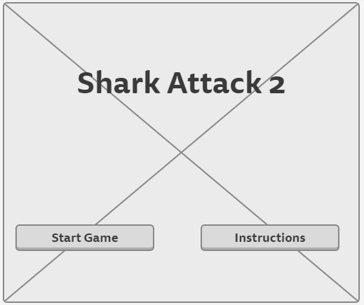

### Instruction Screen

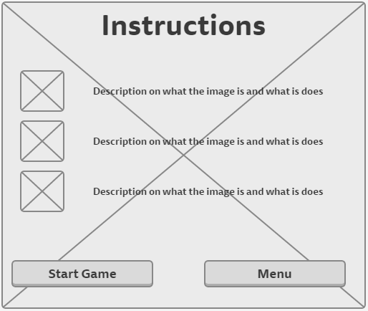

### Playing Screen

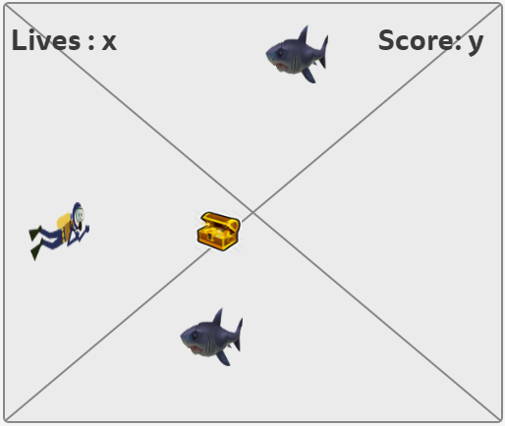

### End Screen

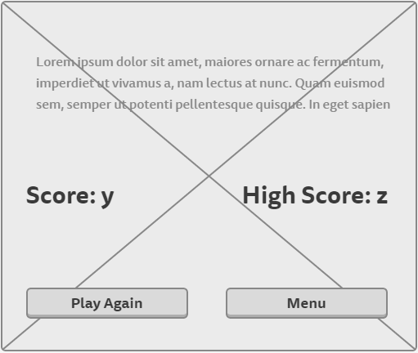

## Menu and Screen Descriptions

### Menu Screen

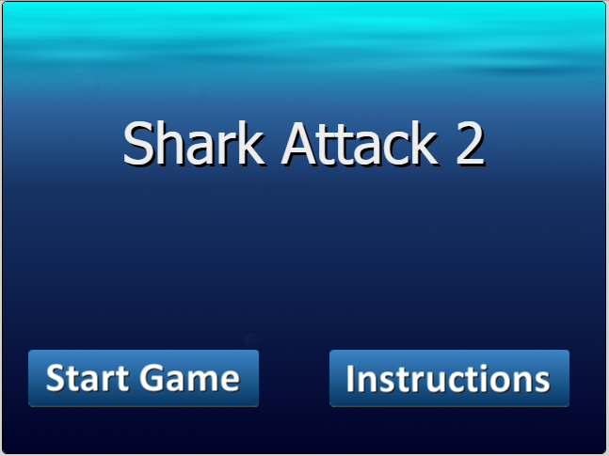

### Instruction Screen

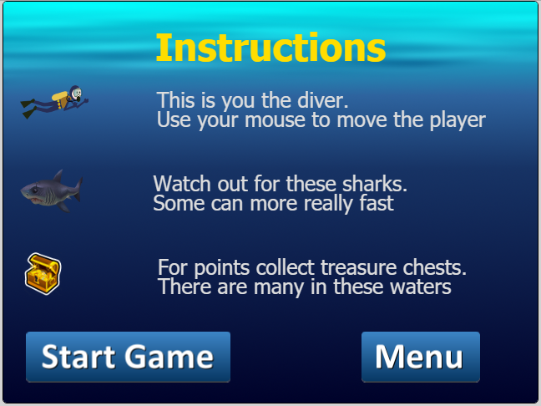

### Playing Screen

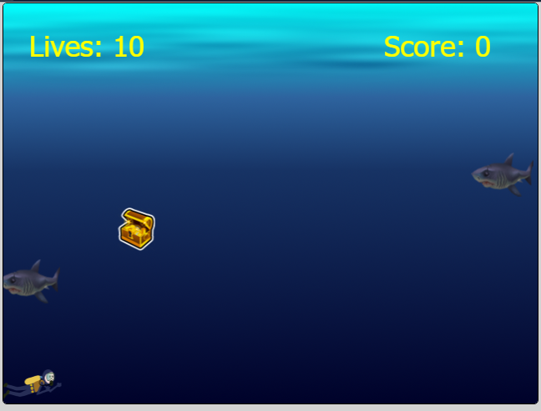

### End Screen

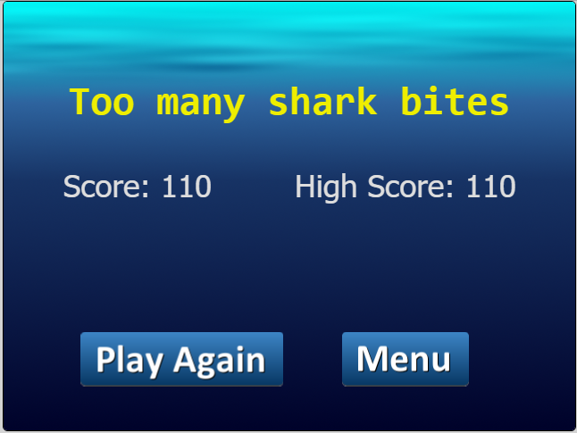

## Characters

The avatar is a male diver. He moves up or down depending on the player’s mouse movement.

## Enemies

The enemies in this game are sharks. They move right to left and sometimes drifts up or down. You lose points if you get bitten.

## Scoring

* You start off with 10 lives and 0 points.
* If you get bitten by a shark, you lose a life, no points are taken away.
* When you collect treasure, you receive 10 points.
* You have no way of getting back lives, and you don’t lose points.
* Game ends when you lose all 10 lives.

## Sound Index

* coin.ogg – sound clip for when diver collects treasure
* comic-bite.ogg – sound clip when diver gets bitten by a shark
* gameover.ogg – sound clip for when player loses all their lives
* theduel.ogg – game background music (kind of creepy)

## Art / Multimedia Index



Background image

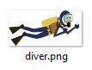Player image – the diver

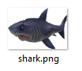The enemy – shark

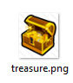

The points – treasure chests

## Game Link:

Microsoft Azure: <https://html5-side-scroller.azurewebsites.net/>